Ideation Phase
Brainstorm & Idea Prioritization Template

Date | 29 January 2026
Team ID | SWTID-2026-7933
Project Name | AI FAQ Assistant
Maximum Marks | 4 Marks

Brainstorm & Idea Prioritization Template:
Brainstorming provides a free and open environment that encourages everyone within a team to participate in the creative thinking process that leads to problem solving. Prioritizing volume over value, out-of-the-box ideas are welcome and built upon, and all participants are encouraged to collaborate, helping each other develop a rich amount of creative solutions.
Use this template in your own brainstorming sessions so your team can unleash their imagination and start shaping concepts even if you're not sitting in the same room.
Reference: https://www.mural.co/templates/brainstorm-and-idea-prioritization
Step-1: Team Gathering, Collaboration and Select the Problem Statement
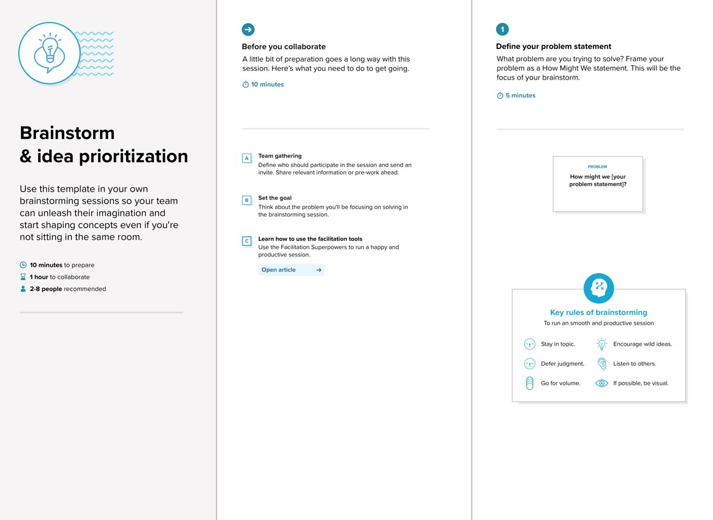
Define your problem statement
How might we build an AI FAQ Assistant that provides quick, accurate and simple answers to frequently asked questions?

Step-2: Brainstorm, Idea Listing and Grouping
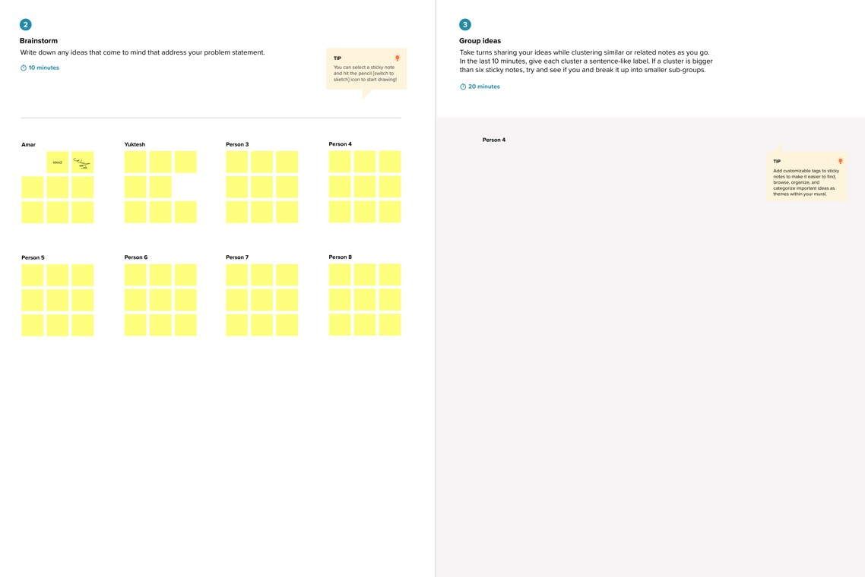
Instant answers
FAQ search
Natural language questions
Accurate answers
Simple responses
24/7 assistance

Step-3: Idea Prioritization High importance & High Feasibility instant answers FAQ search
Accurate answers
High importance & Medium Feasibility
Natural language questions
simple responses
Medium importance & High Feasibility
24/7 assistance


